**TASK 18: Genetics and InheritanceTest [83 marks]**

Students will complete questions relating to Genetics and Inheritance. These questions will address specific content as well as analysis of second hand data. This task will be completed in one session under test conditions.

**Time for the tasks (1 hour)**

* 5 minutes reading time
* 55 minutes working time

**What you need to do:**

* Follow the instructions provided very carefully to complete the test.
* Draw any results in pencil and answer all questions given.
* It is your responsibility to organise your time effectively.
* There is to be no discussion between you or any of your class mates.
* No sharing of any equipment or answers at all.

|  |  |  |  |
| --- | --- | --- | --- |
| Section | Questions | Marks | Your Marks |
| A | Multiple Choice | 20 |  |
| B | Short Answer | 43 |  |
| C | Extended Response | 23 |  |
|  | Total |  | 86 |

**DO NOT TURN THIS PAGE OVER UNTIL YOU ARE TOLD TO**

**ANSWER KEY**

**STUDENT NAME: __________________________________________________________________**

**TEACHER: Mrs Cunningham YEAR: 11**

SECTION A – MULTIPLE CHOICE

Instructions: Indicate your answer on the Multiple Choice answer sheet provided

If you wish to change your answer, put a cross through your original answer, and indicate your new response.

1. Long-stemmed pea plants were crossed with short-stemmed pea plants. All the offspring

were long-stemmed plants

The genotypes of the offspring plants are:

a. either homozygous dominant or heterozygous

b. heterozygous only

c. homozygous dominant only

d homozygous recessive only

2. Recombination occurs during :

a. anaphase of the second meiotic division, as chromosomes separate

b. metaphase of the first meiotic division, as chromosomes are paired

c. interphase as chromosomes are replicated

d. telophase of the first meiotic division, when cytoplasm is divided into two parts

3. Which of the following is NOT a significant source of variation in humans?

a. Random fertilization

b. DNA replication

c. Recombination

d. Non-identical parents

4. Fragile-X syndrome is caused by a single gene defect of the FMR1 gene on the X chromosome, causing mental retardation.

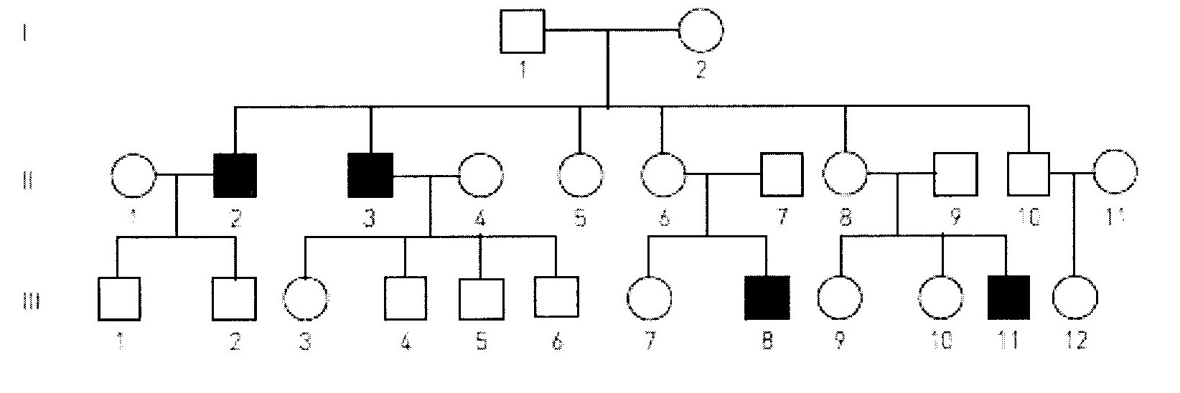

Using the pedigree shown, which one of the following combinations of genotypes is possible for the individuals listed?

a. I 2: XF Xf, II 4: XF Xf, III 6: XF Y

b. I 2: XF Xf, II 4: XF XF, III 6: Xf Y

c. I 2: XF XF, II 4: XF XF, III 6: XF Y

d. I 2: Xf Xf II 4: XF Xf, III 6: Xf Y

5. Before crossing over, two sets of duplicated homologous chromosomes have the following combinations of alleles.

Chromosome I: xyz

Chromosome II: XYZ

If crossing over occurs between the Y and Z loci (~alleles), which of the following shows the possible combination of alleles in gametes formed from this meiotic division?

a. xyz, xyZ, XyZ and XYZ

b. xyz, xyZ, XYZ and XYZ

c. xyz, xyZ, XYz and XYZ

d. Xyz, xyZ, Xyz and XYZ

6. In regards to sex determination, which statement is correct?

a. A zygote with X and Y chromosomes will develop into a female.

b. Two X chromosome ova can fuse to develop into a female with XX chromosomes.

c. Half of all ova have X chromosomes, while the other half have Y chromosomes.

d. Usually, half of all sperm have X chromosomes, while the other half have Y chromosomes.

7. A haemophiliac man and a non-haemophiliac woman, who comes from a family with no history of haemophilia, have a daughter.

Which probability matches this circumstance?

a. There is a 50% chance the daughter has haemophilia

b. There is a 100% chance the daughter is a carrier

c. There is a 50% chance the daughter is homozygous dominant

d. There is a 100% chance the daughter is homozygous recessive.

8. Individuals each receive one set of 23 chromosomes from their mother and another set of 23 chromosomes from their father.

The chance that they have a non-twin sibling with an identical set of chromosomes is about:

a. 1/23

b. ½

c. 0

d. almost certain

9. Two parents who can roll their tongues have one child who cannot tongue roll and one child who can.

What is the probability that the tongue-rolling child is homozygous for that trait?

a. 1/3

b. ½

c. 2/3

d. ¼

10. Non-disjunction producing non-haploid gametes can occur during:

a. the first or second meiotic division.

b. The first meiotic division only.

c. the second meiotic division only

d. mitotic division

11. Fertilization by any particular sperm is:

a. irrelevant because they will all have identical chromosomes.

b. dependant on chromosomes matching

c. controlled by the ovum

d. random.

12. Fragile-X syndrome is caused by a single gene defect of the FMR1 gene on the X chromosome causing mental retardation.



From the pedigree above, what is the probability that individual II 5 is a carrier of Fragile-X syndrome?

a. 0

b. 1

c. ½

d. ¼

13. The principle of segregation states that:

a. hybrids are a mix of two different traits.

b. the offspring of the second cross show both characteristics.

c. each character is represented as one of two traits.

d. each gamete receives only one gene for each trait.

14. One type of colour blindness is determined by a gene on the X chromosome.

Which of the following lists all the possible genotypes that could result from a cross between individuals with the genotypes Xb Y and XB Xb?

a. XB Y, Xb Y, XB XB, XB Xb

b. XB Y, Xb Y, XB XB

c. XB Yb, XbY, XB Xb, XB XB

d. XB Y, Xb Y, XB Xb, Xb Xb

15. Two parents with unattached earlobes have two sons, one with attached earlobes and one with unattached earlobes. The son with unattached earlobes has a child with a woman who has attached earlobes. Their first child has attached earlobes.

What is the probability that their second child has unattached earlobes?

a. ½

b. 3/8

c. ¾

d. ¼

16. Two parents who are not albino have one child that is albino. The probability that a second child would be albino is:

a. 25%

b. 50%

c. 0%

d. 100%

17. One type of colour blindness is determined by a gene on the X chromosome.

Which of the following phenotypes could result from a cross between individuals with the genotypes: Xb Y and XB XB ? [Where B = normal vision]

a. Colourblind male

b. Normal male

c. Normal female non-carrier

d. Colourblind female.

18. Changes in the chromosome number in zygotes:

a. can cause severe birth defects.

b. can cause non-disjunction

c. are more common in zygotes of younger women

d. occur early in pregnancy

19. A father with blood type A and a mother with blood type O have children.

The blood types of these children may be:

a. A

b. O

c. A or O

d. A or B

20. Two parents with normal colour vision have a son born with red-green colour blindness.

What is the probability that if their second child is a daughter, she too will be colourblind?

a. 100%

b. 25%

c. 50%

d, 0%

SECTION B – SHORT ANSWER

Write the correct term for the meanings written in the table below.

|  |  |  |
| --- | --- | --- |
| No. | MEANING | TERMINOLOGY |
| 21 | Produce the same characteristic in succeeding generations when bred among themselves | pure breeding |
| 22 | the mating of two organisms – term used in genetics | a cross |
| 23 | the situation where an individual has the same alleles for a particular characteristic | homozygous |
| 24 | gel electrophoresis is used to make a genetic…. | fingerprint or profile |
| 25 | A male gets his Y chromosome from his…? | father |
| 26 | Huntington’s disease shows this type of inheritance… | Dominant  Genetics |
| 27 | Differences between members of a species are called… | variations |
| 28 | Surname of a British geneticist who devised a square to help with his work on heredity. | Punnett |
| 29 | A non-sex chromosome | autosome |
| 30 | Where a person has only one copy of a chromosome, where normally there would be two | monosomy |

[10 marks]

31. In people, right handedness is due to a dominant gene (R) and left handedness to its recessive allele (r). A right handed woman with a left handed husband has one left handed child and three right handed children.

a. What are the genotypes of the parents?____Mother – Rr Father – rr [1 mark ] __________________________________

b. What phenotypic ratio was expected in the offspring? [Show all working] [4 marks]

Cross = Rr X rr 1

Genotype Phenotype

1

|  |  |  |
| --- | --- | --- |
|  | R | r |
| r | Rr | rr |
| r | Rr | rr |

Rr - 50% right handed - 50% 1

rr – 50% left handed – 50%

Therefore, would expect phenotypic ratio of right to left, of 1 : 1 1

c. How many of the offspring were expected to be left handed? ____half __[ 1 mark]

32. This diagram represents changes in the numbers of chromosomes during reproduction and growth.

Parents 2n 2n

(x)

Gametes

n n

Zygote (y)

2n

(z)

2n

a. What does 2n represent? _____diploid number of chromosomes__do not accept 23/46

b. What does n represent? ____haploid number of chromosomes

c. Identify the process: (x) ______meiosis

(y) _____fertilization

(z) _____mitosis

[5 marks]

33. A woman of blood group A claims that a man of blood group AB is the father of her child. A blood test reveals that the child’s blood group is O.

a. Is it possible the woman’s claim is correct? Show working. [3 marks]

For the child to be blood group O needs to get an “I” from each parent…i.e.

Child: ii OR as evidenced by the Punnett square below

Woman: IA IA or IA i the man cannot be the father he has no.

|  |  |  |
| --- | --- | --- |
|  | IA | “i” |
| IA | IA IA | IAi |
| **IB** | IA **IB** | **IBi** |
|  |  |  |

Man: IA IB

but the man has no “I” to give,

hence the woman’s claim is incorrect .

b. Could the father of the child have been a group B man? Explain your reasoning.

[3 marks]

Yes…If the A group mother is heterozygous for blood group A, and the B blood group man is heterozygous for B group then both will have an I to give, hence it is possible for Blood group B man to have been father of O group child. ii

34. The genetic disorder phenylketonuria (PKU) is caused by a recessive allele (**n**), the dominant allele (**N**) is described as normal.

The family tree below shows the incidence of the disease over three generations.

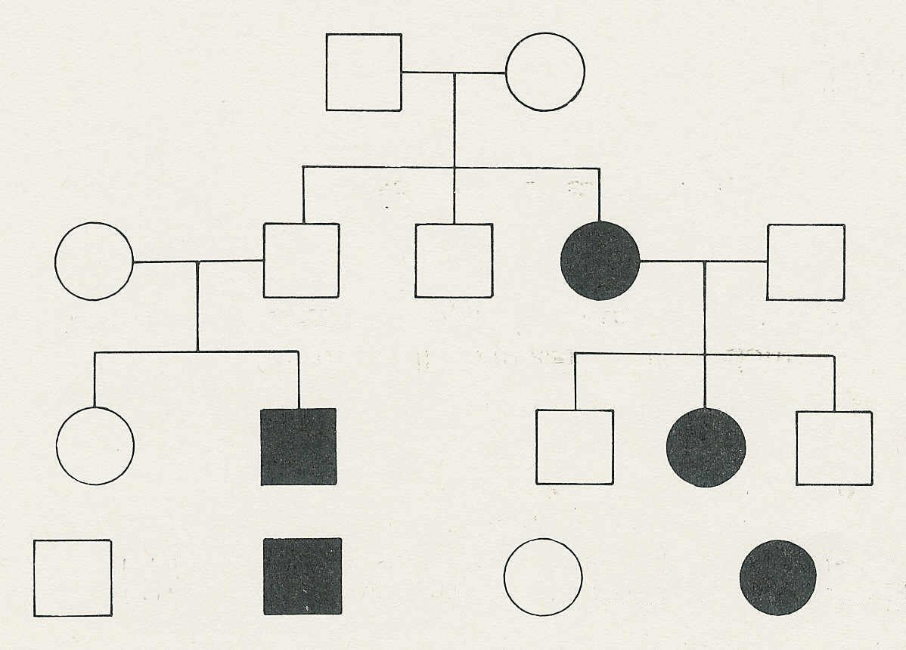

**grandparents**

**parents**

Peter

Alan

husband

Jane

Wife

**children**

KEY

female with PKU

normal female

male with PKU

normal male

(a) What are the possible genotypes of the grandparents?

__________________________Nn__and Nn

[2 marks]

(b) Explain your reasoning.

_______Jane , daughter, has PKU hence received an r from each parent, and as neither has PKU they must be heterozygous

_____________________________________________________________________________

[ 2 marks]

(c) What is the genotype of Jane's husband?

__________________________Nn

[ 2 marks]

(d) Explain your reasoning.

____________________________as they have a child with PKU both must be

[2 marks]

(e) If Jane had been normal, what are the possible genotypes of the grandparents?

__________________ Nn or NN_______________ [2 marks]

35. A woman is heterozygous for a sex-linked recessive characteristic. She has children with a man who has the characteristic.

What will be the proportion of the genotypes and phenotypes in their offspring?

Show all working [6 marks]

This one is to see that they set everything out correctly, and come up with what the question is asking.

|  |  |  |
| --- | --- | --- |
|  | XR | Xr |
| Xr | XR Xr | Xr Xr |
| Y | XR Y | Xr Y |

Let recessive characteristic be r

Let dominant characteristic be R 1

Genotype of mother: XR Xr

Genotype of father: Xr Y 1

1

Cross: : XR Xr x Xr Y 1

|  |  |  |  |
| --- | --- | --- | --- |
| Genotype | % | Phenotype | % |
| XR Xr | 25 | Normal, carrier female | 25 |
| Xr Xr | 25 | affected female | 25 |
| XR Y | 25 | Normal male | 25 |
| Xr Y | 25 | affected male | 25 |

1 1

**SECTION C – EXTENDED RESPONSE – WRITE YOUR RESPONSE IN THE SPACE FOLLOWING THE QUESTION. [23 marks]**

36. a. Describe three inheritance processes and explain how they introduce variation into a species.

[15 marks]

b. Using a specific example, explain the role of a genetic counselling. [ 8 marks]

a.

The ‘How to produce variation’ column…I think it’s self explanatory…indicating the difference in characteristic, and using the expression…leading to variation

|  |  |  |  |
| --- | --- | --- | --- |
| NAME – 1 | DESCRIPTION - 1 | HOW PRODUCE VARIATION 2 | 5 PER PROCESS |
| Random assortment (of chromosomes during meiosis) | during meiosis chromosomes move to either pole of the cell – which one they go to does not influence which one another chromosome goes to | As chromosomes are randomly sorted, therefore genes and characteristics are mixed, this leads to variation |  |
| Crossing over | chromatids break and reattach to other chromatids during the first division of meiosis | could do a diagram  hence alleles on the chromatid are moved to different chromosomes (same number, different verson), giving a different combination…hence variation |  |
| Non-disjunction | during first and second division of meiosis when chromosome pairs separate…sometimes they don’t…so we can have an extra have 0, 1, 3 chromosomes, in the ovum | hence we get a different to normal no. of chromosomes.  Having differing no. of chromosomes, means different no of genes, and hence characteristics change…i.e. variation |  |
| Mutation | sudden change in the genetic code; or sudden permanent change in DNA/genes | changing bases in DNA changes what the gene is coding for and hence different characteristics result in variation. |  |
| Random fertilization | fertilization occurs in the fallopian tube…the ovum is present – randomly chosen – the sperm is one of millions, hence a random selection | With so much randomness, there will be lots of variation |  |
| Epigenetic factors | altering the expression of a gene without changing gene structure…can be inherited | hence there is the ability to have different characteristics…leading to variation. |  |

b. using something like Thalassemia/Downs syndrome/ Huntington’s disease /some condition in their family …they have a previous child with a disease1; other people in their family have a disease1; their partner has a disease 1

as the trigger for a person/couple to seek information from their GP in the first instance, who would refer them onto a Genetic Counsellor… to find out about the risk of having a child with the disorder.1

The genetic counsellor will look at the incidence of the disorder in the family tree1,,, they may be able to work out a probability1…modern techniques can now detect disorders before birth1

The couple can then decide whether to risk having a child with the disorder , or terminate the pregnancy.1

The Genetic Counsellor gives information and advice, but does not decide for the couple, they have that responsibility.1

8 marks – two triggers/, the rest as given.